EXPERIMENT NO: 9
RING COUNTER & JOHNSON (TWISTED RING) COUNTER

AIM:

To design and set up 4-bit ring counter and Johnson counter using flipflops.

COMPONENTS REQUIRED:

SL No. | COMPONENT | SPECIFICATION | QTY
1. | D FLIPFLOP | IC 7474 | 2
2. | IC TRAINER KIT | - | 1

THEORY:
Ring counter and Johnson counter are two important shift counters.

RING COUNTER:
It is a shift counter shifting the sequence in a cyclic nature. A ring counter is constructed using D flip flops by connecting Q output from one flip flop to the D input of the next flipflops respectively. The output of the final flip flop is connected to the input of the first flipflop. To start the counter, the flipflops should be initialized using preset and clear inputs. For each clock pulse the number gets shifted like in a ring. Ring counter is called a divide by N counter where N is the number of flipflops. Ring counter divides the clock frequency by N. Ring counters are used for switching devices or lamps in a particular order ,rotate the stepper motor etc.

JOHNSON COUNTER:
A ring counter can be converted to a Johnson counter by connecting ~Q output of the last flipflop to the D input of the first flip flop respectively. The mod number of the counter is double of that of the ring counter. Johnson counter also called twisted ring counter or divide by 2n counter.

RING COUNTER

TRUTH TABLE

CLK | QA | QB | QC | QD
1 | 1 | 0 | 0 | 0
2 | 0 | 1 | 0 | 0
3 | 0 | 0 | 1 | 0
4 | 0 | 0 | 0 | 1

WAVEFORMS:

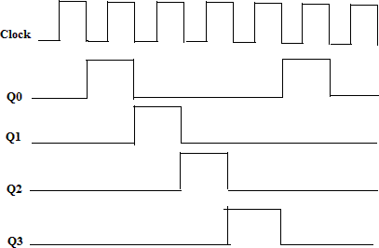

CIRCUIT DIAGRAM OF RING COUNTER USING D FLIPFLOP:
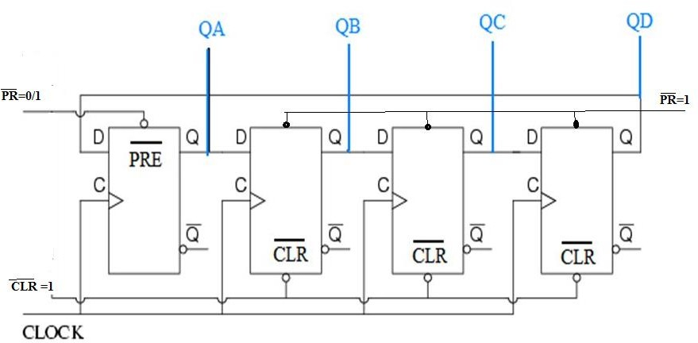

JOHNSON COUNTER:

TRUTH TABLE

CLK | QA | QB | QC | QD
0 | 0 | 0 | 0 | 0
1 | 1 | 0 | 0 | 0
2 | 1 | 1 | 0 | 0
3 | 1 | 1 | 1 | 0
4 | 1 | 1 | 1 | 1
5 | 0 | 1 | 1 | 1
6 | 0 | 0 | 1 | 1
7 | 0 | 0 | 0 | 1

WAVEFORMS:

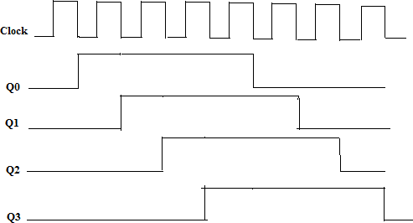

CIRCUIT DIAGRAM FOR JOHNSON COUNTER USING D FLIP FLOP:
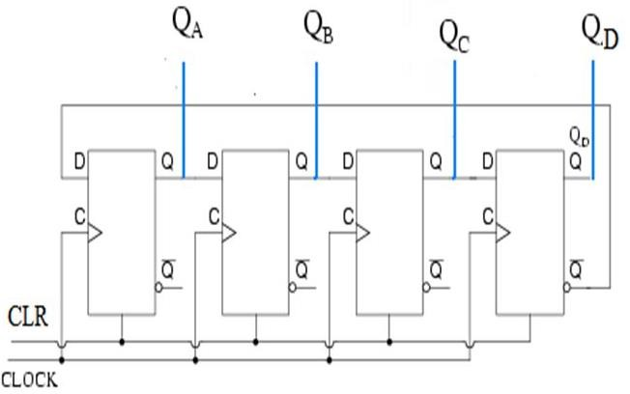

PROCEDURE:

- Set up the ring counter to shift 1000 as shown in figure. Set first flip flop output to logic 1 by applying logic 0 to its preset input. After presetting the output , inactivate the preset. Clear the remaining Q outputs to logic 0 by applying logic 0 to clear pins. After clearing the outputs inactivate clear pins.
- Apply clock pulse and observe the outputs. Repeat the experiment to shift other binary pattern.
- Set up the Johnson counter. Clear all Q outputs by connecting clear pins to logic 0.After clearing deactivate clear pins. Apply clock pulses and verify its operations.

RESULT:

Implemented Ring and Johnson counter using D flip flop and verified the truth table.

